Big-O
For each of the functions f(N) given below, indicate the tightest bound possible (in other words, giving O(2N) as the answer to every question is not likely to result in many points). Unless otherwise specified, all logs are base 2. You MUST choose your answer from the following (not given in any particular order), each of which could be re-used (could be the answer for more than one of a) – h)):

O(N2), O(N½)O(N3 log N), O(N log N), O(N), O(N2 log N), O(N5), O(2N), O(N3), O(log N), O(1), O(N4), O(N12)O(NN), O(N6), O(N8), O(N9), O(N10)

You do not need to explain your answer.
a) f(N) = (1/2) (N log N) + (log N) 2 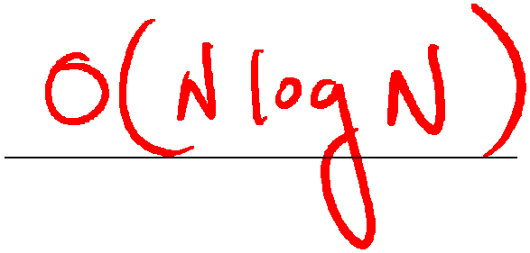

b) f(N) = N2 (N + N log N + 1000) 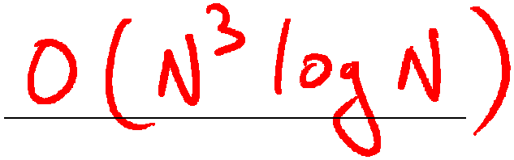

c) f(N) = N2 log N + 2N 

d) f(N) = ( (1/2) (3N + 5 + N) ) 4 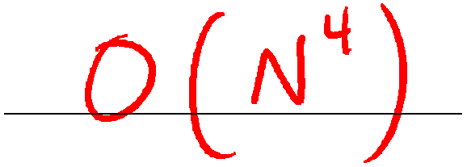

e) f(N) = (2N + 5 + N4 ) / N
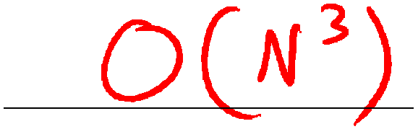

f) f(N) = log10(2 )
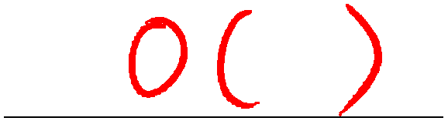



N

g) f(N) = N! + 2N
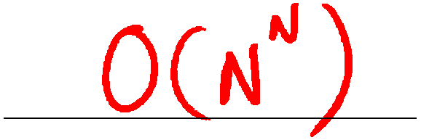

h) f(N) = (N N N N + 2N)2
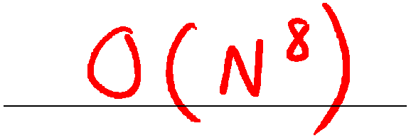

Big-O
For each of the functions f(N) given below, indicate the tightest bound possible (in other words, giving O(2N) as the answer to every question is not likely to result in many points). Unless otherwise specified, all logs are base 2. You MUST choose your answer from the following (not given in any particular order), each of which could be re-used (could be the answer for more than one of a) – h)):

O(N2), O(N½)O(N3 log N), O(N log N), O(N), O(N2 log N), O(N5), O(2N), O(N3), O(log N), O(1), O(N4), O(N12)O(NN), O(N6), O(N8), O(N9)
You do not need to explain your answer. a) f(N) = N (N2 log N + N2)
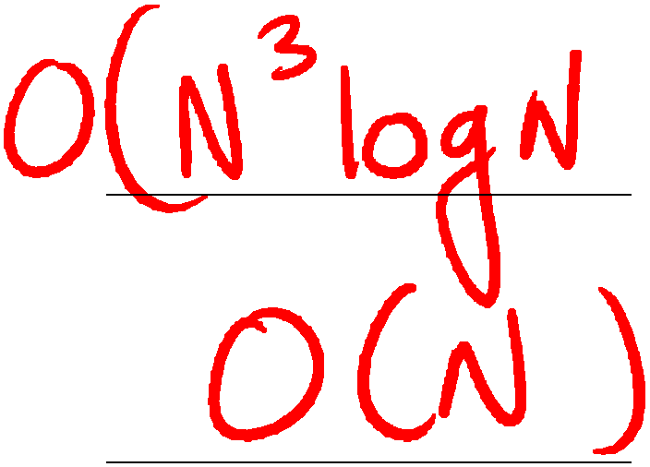



b) f(N) = log16 (2 )
N

c) f(N) = (N/4) log (N/4) + N/4
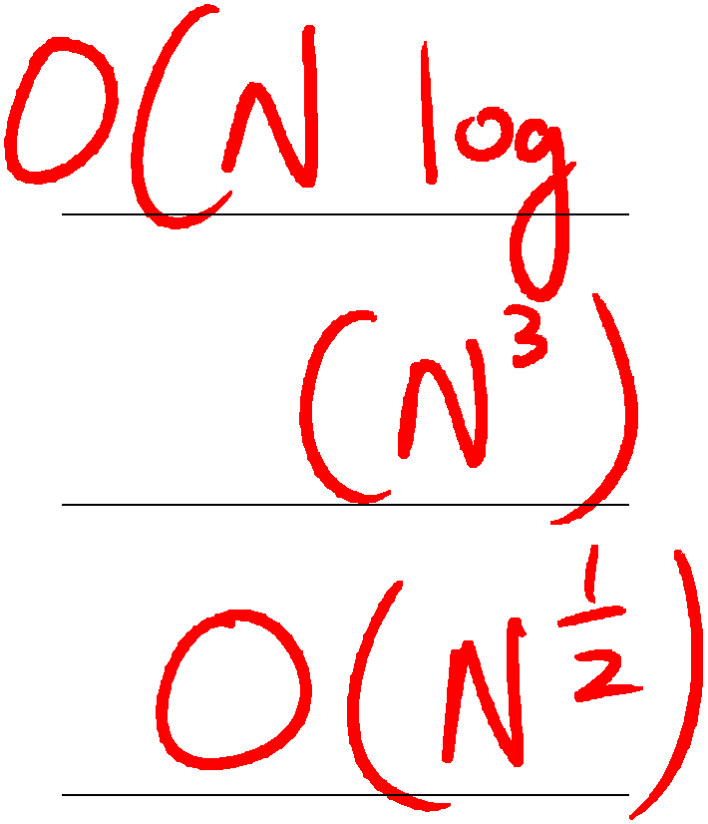







d) f(N) = (2N + 2N) 3

e) f(N) = N½ + log N

f) f(N) = N log (1003) 

g) f(N) = (N N N N)3 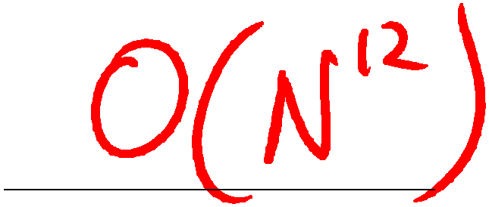

h) f(N) = (N3 + 2N) / N
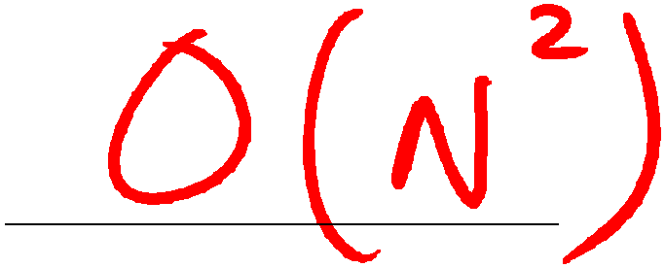

Big-O
For each of the functions f(N) given below, indicate the tightest bound possible (in other words, giving O(2N) as the answer to every question is not likely to result in many points). Unless otherwise specified, all logs are base 2. You MUST choose your answer from the following (not given in any particular order), each of which could be re-used (could be the answer for more than one of a) – h)):

O(N2), O(N1/2), O(N1/4), O(log3 N), O(N), O(N2 log N), O(N5), O(2N), O(N3), O(N8), O(log4 N), O(N log3 N), O(N2 log2 N), O(log N), O(1), O(N4), O(NN), O(N6), O(N log2 N), O(log log N)

You do not need to explain your answer.

a) f(N) = N1/2 + log3 N O(N1/2)

b) f(N) = 100 log N + N1/4 O(N1/4)

c) f(N) = N2 log N2 + 2 N log2 N O(N2 log N)

d) f(N) = ( N (100N + 5 + N 3) )2 O(N8)

e) f(N) = 1000 log log N + log N O(log N)

f) f(N) = log16(2
N) O(N)

g) f(N) = N2  (log N3 – log N)+ N 2 O(N2 log N)

h) f(N) = (N log N + 2N)2 O(N2 log2 N)

Big-O
For each of the functions f(N) given below, indicate the tightest bound possible (in other words, giving O(2N) as the answer to every question is not likely to result in many points). Unless otherwise specified, all logs are base 2. You MUST choose your answer from the following (not given in any particular order), each of which could be re-used (could be the answer for more than one of a) – h)):

O(N2), O(N1/2), O(N1/4), O(log3 N), O(N), O(N2 log N), O(log8 N), O(N5), O(2N), O(N3), O(N8), O(log4 N), O(N log3 N), O( log2 N), O(log N), O(1), O(N3 log N), O(N4), O(NN), O(N6),
O(N log2 N), O(log log N), O(log4 N), O(N log N)

You do not need to explain your answer.

a) f(N) = N3  (4log N – log N)+ (N 2)2

O(N4)

b) f(N) = log8(2
4N)
O(N)

c) f(N) = 500 N log N + N2 log N
O(N2 log N)

d) f(N) = ( N (N + 1)2)
O(N3)

e) f(N) = log N4 + log2 N
O( log2 N)

f) f(N) = N + log N + N1/8
O(N)

g) f(N) = N1/4 + (log4 N)2
O(N1/4)

h) f(N) = N3  N2 + (N + 2N)2
O(N5)

